1. Product Overview
The WIN-IO RS485 to RS485 Loop Module is a reliable and efficient solution designed for seamless signal continuity and validation in Modbus RTU communication networks. This module enables users to verify data integrity by looping RS485 signals between connected devices, ensuring accurate transmission and reception of Modbus data.
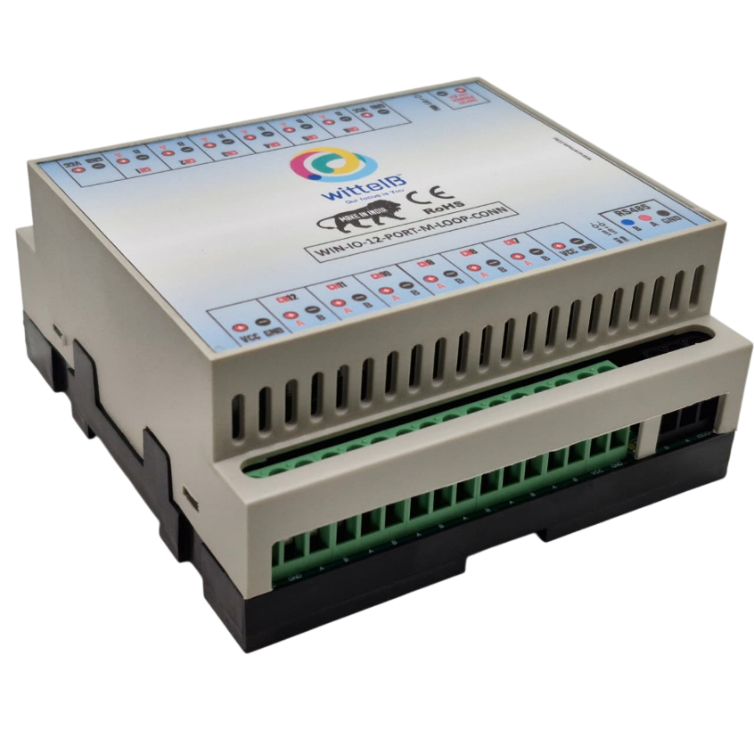
In typical operation, the module connects to Modbus-enabled devices via RS485 communication lines (A and B terminals). By interchanging or looping the A and B lines through the module, the same Modbus RTU data transmitted from the master or device is received back, allowing easy testing, diagnostics, and validation of communication links.
Fig.1 - Product Image
The device supports multi-channel connectivity, offering up to 12 independent RS485 channels, making it suitable for complex industrial networks. Each channel can be integrated into a loop configuration, allowing multiple Modbus devices to be connected in a daisy-chain or loop topology. This ensures consistent data flow across all nodes and simplifies troubleshooting in large-scale deployments. Designed for industrial environments, the module ensures stable communication, reduces signal loss, and enhances system reliability. It is ideal for use in automation systems, SCADA networks, industrial control panels, and field device testing setups.
2. Key Features
- Supports Modbus RTU protocol communication
- RS485 to RS485 loopback functionality for data validation
- Up to 12 independent communication channels
- Simple connection via A and B differential lines
- Enables loop topology / daisy-chain network configuration
- Improves communication testing and fault detection
- Robust design for industrial applications
3. Applications
- Industrial Automation Systems
- SCADA & Monitoring Systems
- Modbus Network Testing & Debugging
- Control Panels & Field Device Integration
4. Technical Specifications
- Power Supply: 12–24V DC
- Interface: RS485 (A, B Differential)
- Channels: 12 Independent RS485 Channels
- Topology: Loop / Daisy Chain
- Baud Rate: 1200 to 115200 bps
- Data Format: 8 Data Bits, 1/2 Stop Bits, Parity (None/Even/Odd)

- Certifications:

5. Recommended Cable Electrical Characteristics
- Cable Type: 22 AWG, Shielded Twisted Pair
- Conductor Material: Tinned Copper (Recommended)
- Conductor DCR: 14.7 Ω / 1000 ft (Nominal)
- Capacitance: 11 pF / ft (Conductor to Conductor)
- Insertion Loss: ≤ 0.5 dB / 100 ft

Power Supply 12/24Vdc

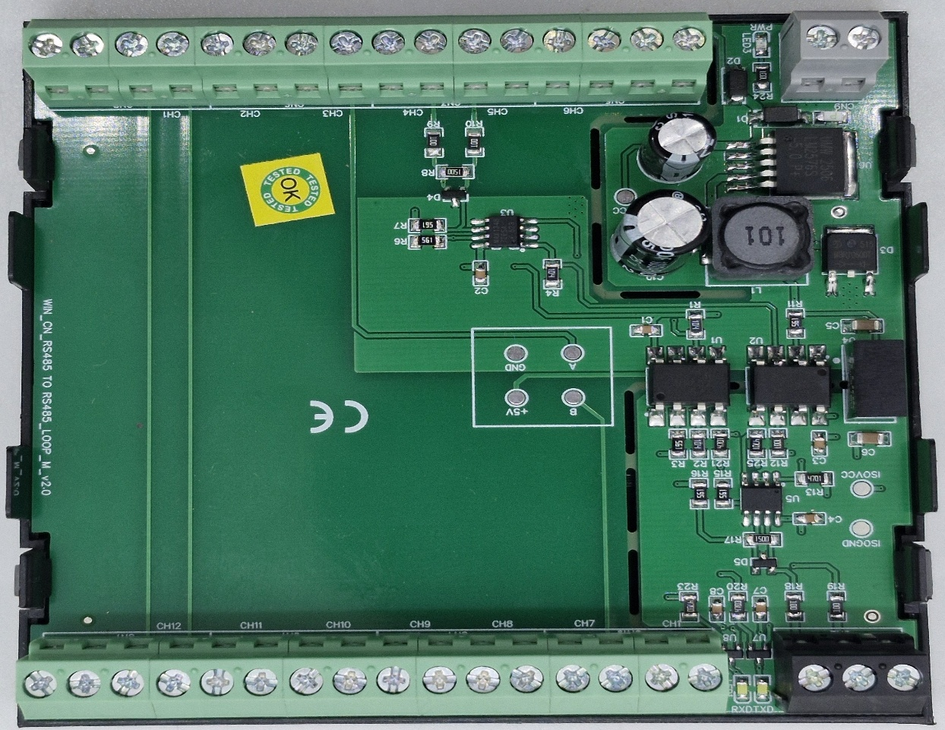
VCC | GND
VCC | GND
Loop indication (A’s and B’s RS485 LOOP)

VCC | GND
VCC | GND
Loop indication (A’s and B’s RS485 LOOP)
RS 485 A, B

Contact Information
Augmatic Technologies Pvt. Ltd.,
Plot no 6, Shah Industrial Estate II,
Kotambi,
Vadodara – 391510.
Email – Sales@wittelb.com
Support: support@wittelb.raiseaticket.com / +91 94038 92805

